**Multiverse Marbles**

*This game starts out deceptively simple: Push your marbles towards their goals while pushing out your opponent. But here’s the twist: In every round you get to change the rules of the game. From where you start, to what you do, to how you win. One by one you create a completely different game, always learning and never playing the exact same strategy twice.*

**Players: 2 Playtime: 15+ minutes Age: 7+**

# **Initial Setup**

## Components

* 1 board
* 10 blue marbles
* 10 green marbles
* 2 blockers
* 1 black hole
* 38 rule cards
* 9 additional cards



1. Put the 7-by-7 **grid** in between both players, with the two **green goals** (corners)towards one player and the other two **blue goals** facing the other player.
2. Take the first six **rule cards** from the boxand place them next to grid in a 3-by-2 **rules display** (Top: 1.1, 2.1 and 3.1; Bottom: 4.1, 5.1 and 6.1).
3. Shuffle all remaining rule cards and put them in a face-down **draw** **pile** next to the rules display.
4. Now place the green and blue **marbles** onto the grid as displayed on rule card 1.1 (“Setup”).
5. Put the **box** on the other side and keep the two black, hexagonal **blockers** in there.
6. Choose which player should go first.

# **How to play your first game**

The first game is slightly simplified, to let you get the hang of it quickly. Try not to over-think it. Play a fast and loose game to get a feeling for the game’s dynamics, and then quickly move on to the 2nd game. The rules of the game are simple:

* Both players take alternating turns.
* **Rule card 1.1 (SETUP)** shows the key elements on the play field: Every player controls the ten marbles of their color and tries to reach the goals of the same color on the opposite corners.
* **Rule card 2.1 (VICTORY)** show how you win:
  + Have one of your marbles on each of the two goal spaces of your color.
  + ASIDE: You also win, if your opponent cannot do this anymore (because they only have 1 marble left).
* **Rule card 3.1 (MOVEMENT)** explains your main action: Every turn you **move** one of your marbles by one **space** in any of the 8 directions (yes, this includes the 4 diagonals). Movement always goes “through empty space”. If you move into another marble, then this is a push:
* As shown by **rule card 4.1 (PUSH)**, if you move into one (or more) of your marbles, then these get **pushed** by one space in that direction (always in a straight or diagonal line).
* You can also push your opponent’s marbles. But as **rule card 5.1 (PUSH REQ.)** states: You always need to push more of your own marbles than the number of opponent marbles you are trying to push.
* Here are some valid pushes: Here you cannot push: 
* And finally, the last rule. **Rule card 6.1 (PUSH OFF)** states, that any marble pushed out of the 7-by-7 grid gets removed from the game (put it in the box). This is true for all spaces, including the goals. Even a marble on a goal can be pushed out.

This is it. You are now ready to play your first game. Get started and remember: It is best to play fast and learn. **You can always concede a game or offer your opponent a draw.**

The “real game” starts with your second game. Read the FAQ on page 3, if you have any problems playing or find any edge cases. After your first game, read on under “Setup for the second game”.

Now go and play!

# **Frequently Asked Questions (FAQ)**

You don’t have to read these to get started. But if you run into any unclear situations: Look here and find the answers.

1. **The difference between pushing and moving?** Moving never affects the position of your opponent’s marbles. Pushing can do so (but you can also just push your own marbles).
2. **You have to make a move**. Even if that makes your position worse.
3. **You are allowed to move or push one of your own pieces off the grid**. Even if that means this piece is removed.
4. **The chain rule**: Chains of marbles that have a player’s colors interrupted by their opponent, always need to satisfy the current 5.x PUSH REQ rules card. Here two examples from the base game:
   1. This works: **>BBBGGB** (Blue is pushing green’s two marbles with their three marbles, and then those two green marbles push the remaining blue one.) So would **>BBBBGGB** or **BGGBBB<**.
   2. This does not work: **>BBGB** (The two blue marbles can push the green marble but that one cannot push the single blue marble at the end.) Equally, these do not work: **>BBBGGBB** or **BGGB<**.
5. **You cannot push around corners**. A push is always in a horizontal, vertical or diagonal direction and it cannot “turn a corner”.
6. **What happens if someone runs out of marbles?** If a player has fewer marbles than currently required to win (so less than 2), they instantly lose.
7. **If the same game state appears for the third time in a game, the game ends in a draw**. But be aware of the “cannot un-do your opponent’s move right away” rule above. This should be very uncommon.

# 

# **Setup for your second game**

Now that you have the hang of the base game, let’s get to all that rule mutation goodness!

1. Put all marbles back onto the grid, as shown on card 1.1 (SETUP).
2. Now flip over the top two cards of the draw pile and put them next to the current rule grid, as shown below.
3. Rejection sampling: If you draw a card which shares one of the letters in the bottom right (for example “ACE” and “E”), with another card drawn or in the rule display, then discard this card and draw a new one instead. This means that these cards are not compatible.
4. For this second game, the loser of the first game becomes the new start player.



# **How to play your second game\***

* and all future games.

In your first game your only action was to move a marble (and with it push some other marbles). Now you have a new ability:

**Change a rule:** At any time during the game, *instead* of moving one of your marbles, you can select one of the two additional rule cards and put them on top the rule card on the grid of the same color (this means any card with, say, a 4 on the top left would go over the existing card with a 4). This means that you have just changed the rules of the game. Forever. Thoroughly read what the card says. Only the top cards on the rule grid are active.

There are six **types of rules**:

* **Setup**: How to set up the game board and marbles initially.
* **Victory**: How to win (or lose) a game.
* **Movement**: How to move one (or multiple) of your marbles.
* **Push Direction**: In which direction (and how far) marbles can be pushed.
* **Push Requirement**: How many marbles you need to push your opponent.
* **Push Ou**t: What happens, when a marble gets pushed out of the game.

**Every player can only change one rule per game.** If you change the first rule, it is up to your opponent to decide if and when they want to change a second rule. 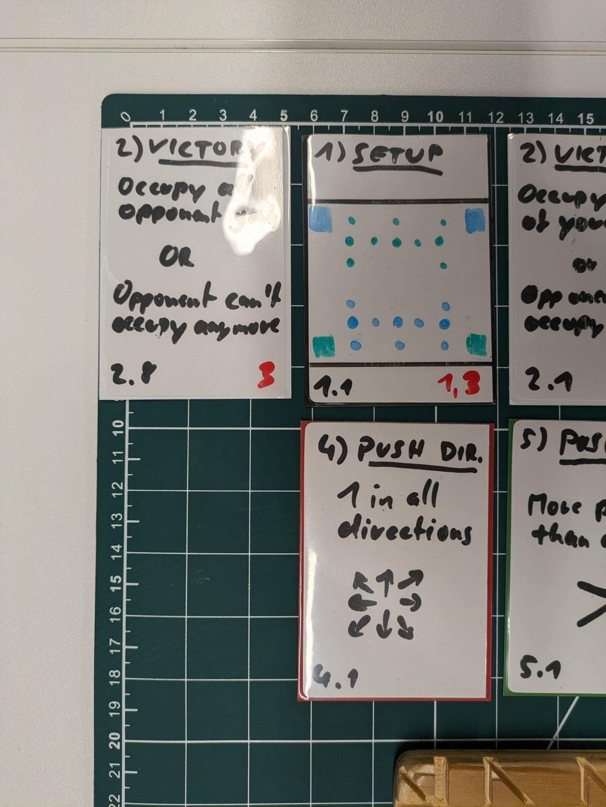

**Some rule cards are incompatible with others**. If a card drawn has a red number in the bottom right which matches the red number of an existing card in the rule display, discard the new card and draw a replacement.

**If you draw a 1.x SETUP card**: This will automatically effect your next game. Place it on top of the current 1.x SETUP card on the rule display and draw another card to replace it. Then, in your next game, start with this setup. If you draw multiple of these cards in a row, continue replacing them (only the top card of the rule display stack applies).

At the end of the game:

**You will always change a rule each game.** If a game ends, without any player changing a rule, then the losing player must choose one of the two cards on display and put them onto the rule display.

**Any remaining rule cards now get discarded** (put them on a face-down discard pile) and you draw two new cards for your next game.

Before you start: Go over the current, existing rules together. So you remember what you are currently playing.

Now play!

# **All Rule Cards and Additional FAQ**

1. **You cannot un-do your opponent’s move right away**. Any move that ends in the same game state as it was before your opponent’s last move, is invalid.
2. When a marble gets removed from the grid, and there is a rule that says that it needs to be returned to the grid, **do this right away**.

| # | ID | Group | Title | Description | Icon | Incompatible | Clarifications |
| --- | --- | --- | --- | --- | --- | --- | --- |
| TBD: Number of card in the deck, so you can (re) set up the deck | 1.1 | SETUP | Facing Worlds | - | SETUP | AC | - |
| TBD: Number of card in the deck, so you can (re) set up the deck | 1.2 | SETUP | Tornado | - | SETUP | ACE | Blockers do not allow any movement, pushing or spawning on the space they are on. |
| TBD: Number of card in the deck, so you can (re) set up the deck | 1.3 | SETUP | Expansion | - | SETUP | B | - |
| TBD: Number of card in the deck, so you can (re) set up the deck | 1.4 | SETUP | Expansion II | - | SETUP | ABE | Blockers do not allow any movement, pushing or spawning on the space they are on. |
| TBD: Number of card in the deck, so you can (re) set up the deck | 1.5 | SETUP | Focal Points | - | SETUP | C | Blockers do not allow any movement, pushing or spawning on the space they are on. |
| TBD: Number of card in the deck, so you can (re) set up the deck | 1.6 | SETUP | Cornered | - | SETUP | C | Blockers do not allow any movement, pushing or spawning on the space they are on. |
| TBD: Number of card in the deck, so you can (re) set up the deck | 1.7 | SETUP | Line Dance | - | SETUP | D | Blockers do not allow any movement, pushing or spawning on the space they are on. |
| TBD: Number of card in the deck, so you can (re) set up the deck | 1.8 | SETUP | Black Hole | - | SETUP | E | Black holes act like the edge of the board for all purposes. Pieces can be pushed out or through them. |
| TBD: Number of card in the deck, so you can (re) set up the deck | 2.1 | VICTORY | Your color | Occupy both goals of your color to win. | CLOCK | - | - |
| TBD: Number of card in the deck, so you can (re) set up the deck | 2.2 | VICTORY | Their color | Occupy both goals of your opponent’s color to win. | CLOCK | C | - |
| TBD: Number of card in the deck, so you can (re) set up the deck | 2.3 | VICTORY | One of each | Occupy one goal of each color to win. | CLOCK | BD | - |
| TBD: Number of card in the deck, so you can (re) set up the deck | 2.4 | VICTORY | Diagonal | Occupy two opposing goals and the center to win. | CLOCK | E | - |
| TBD: Number of card in the deck, so you can (re) set up the deck | 2.5 | VICTORY | Any three | Occupy any three goals to win. | CLOCK | - | - |
| TBD: Number of card in the deck, so you can (re) set up the deck | 2.6 | VICTORY | Two plus one | Occupy two adjacent goals and the center to win. | CLOCK | E | - |
| TBD: Number of card in the deck, so you can (re) set up the deck | 3.1 | MOVEMENT | Move 1 in any | You can move one of your pieces by one space in any direction. | LIGHTNING | - | - |
| TBD: Number of card in the deck, so you can (re) set up the deck | 3.2 | MOVEMENT | Rook++ | Move one piece by one space diagonally or as far as you want in the cardinal directions. | CLOCK | - | - |
| TBD: Number of card in the deck, so you can (re) set up the deck | 3.3 | MOVEMENT | Bishop++ | Move one piece by one space in the cardinal directions or as far as you want diagonally. | CLOCK | - | - |
| TBD: Number of card in the deck, so you can (re) set up the deck | 3.4 | MOVEMENT | Move 3 in any | Move one piece by up to three spaces in any direction. | CLOCK | - | - |
| TBD: Number of card in the deck, so you can (re) set up the deck | 3.5 | MOVEMENT | Double move | Move one piece twice or two pieces once, in any direction. | CLOCK | - | - |
| TBD: Number of card in the deck, so you can (re) set up the deck | 3.6 | MOVEMENT | Sidestep | Move by one space in any direction or move a line of pieces diagonally or perpendicular. | LIGHTNING | - | - |
| TBD: Number of card in the deck, so you can (re) set up the deck | 3.7 | MOVEMENT | Leapfrog | Move by one space in any direction or jump over one opposing piece or a blocker. | CLOCK | - | Leapfrogging can only be done once per turn. It cannot be chained. |
| TBD: Number of card in the deck, so you can (re) set up the deck | 4.1 | PUSH DIRECTION | Push 1 in any | You can push a group of pieces by one space in any direction. | LIGHTNING | - | - |
| TBD: Number of card in the deck, so you can (re) set up the deck | 4.2 | PUSH DIRECTION | Twice Fwd/Back | Push once in any direction or up to twice forward or backward. | LIGHTNING | - | If two marbles get pushed out of the board and need to be respawned, this is done in the order they got pushed out. |
| TBD: Number of card in the deck, so you can (re) set up the deck | 4.3 | PUSH DIRECTION | Twice Sideways | Push once in any direction or up to twice sideways. | LIGHTNING | - | If two marbles get pushed out of the board and need to be respawned, this is done in the order they got pushed out. |
| TBD: Number of card in the deck, so you can (re) set up the deck | 4.4 | PUSH DIRECTION | Twice Diagonal | Push once in any direction or up to twice diagonally. | LIGHTNING | - | If two marbles get pushed out of the board and need to be respawned, this is done in the order they got pushed out. |
| TBD: Number of card in the deck, so you can (re) set up the deck | 4.5 | PUSH DIRECTION | Must push | You must push a group of opposing pieces by one space, if you can. | LIGHTNING | - | This applies to both pushing your opponent's marbles and your own. |
| TBD: Number of card in the deck, so you can (re) set up the deck | 5.1 | PUSH REQUIREMENT | More | You can push your opponent’s pieces if you use more pieces. | CLOCK | - | This does not apply to your own marbles. You can always push your own marbles with any number. |
| TBD: Number of card in the deck, so you can (re) set up the deck | 5.2 | PUSH REQUIREMENT | More or equal | You need more or equal numbers to push. Do not split your line while pushing the opponent. | CLOCK | - | Only consider adjacent pieces in the line you are pushing on. Any pieces that are perpendicular or diagonally adjacent don't matter. |
| TBD: Number of card in the deck, so you can (re) set up the deck | 5.3 | PUSH REQUIREMENT | Equal | You need exactly equal numbers to push. Do not split your line while pushing the opponent. | CLOCK | - | Only consider adjacent pieces in the line you are pushing on. Any pieces that are perpendicular or diagonally adjacent don't matter. |
| TBD: Number of card in the deck, so you can (re) set up the deck | 5.4 | PUSH REQUIREMENT | Fewer or equal | You need fewer or equal numbers to push. Do not split your line while pushing the opponent. | CLOCK | - | Only consider adjacent pieces in the line you are pushing on. Any pieces that are perpendicular or diagonally adjacent don't matter. |
| TBD: Number of card in the deck, so you can (re) set up the deck | 5.5 | PUSH REQUIREMENT | Fewer or more | You can push your opponent’s pieces if you use fewer or more pieces. | CLOCK | - | - |
| TBD: Number of card in the deck, so you can (re) set up the deck | 6.1 | PUSH OUT | Out is gone | All pieces pushed off the board are removed from play. | LIGHTNING | - | - |
| TBD: Number of card in the deck, so you can (re) set up the deck | 6.2 | PUSH OUT | Center if free | Pieces respawn in the center, if it is free. Else they are removed. | LIGHTNING | - | - |
| TBD: Number of card in the deck, so you can (re) set up the deck | 6.3 | PUSH OUT | Center replace | Pieces respawn in the center. Remove any existing piece there. | CLOCK | - | - |
| TBD: Number of card in the deck, so you can (re) set up the deck | 6.4 | PUSH OUT | Respawn badly | Your pieces respawn in a free space of your opponent’s choice. | LIGHTNING | - | "The opponent" here means the person who does not control the piece. It does not matter who pushed out a marble. |
| TBD: Number of card in the deck, so you can (re) set up the deck | 6.5 | PUSH OUT | Wrap around | You can push through (but not move) to the opposite end of the line. | CLOCK | - | This also means that rules such as "do not split your line" apply for the whole line, even "through" the edge of the board. There is, in fact, no edge anymore. All lines are now cyclical. |
| TBD: Number of card in the deck, so you can (re) set up the deck | 6.6 | PUSH OUT | Teleport if free | Pieces teleport to the other end of the line, if that space is free. Else they are removed. | CLOCK | - | - |
| TBD: Number of card in the deck, so you can (re) set up the deck | 6.7 | PUSH OUT | Teleport Replace | Pieces teleport to the other end of the line. Remove any existing piece in that space. | CLOCK | - | - |

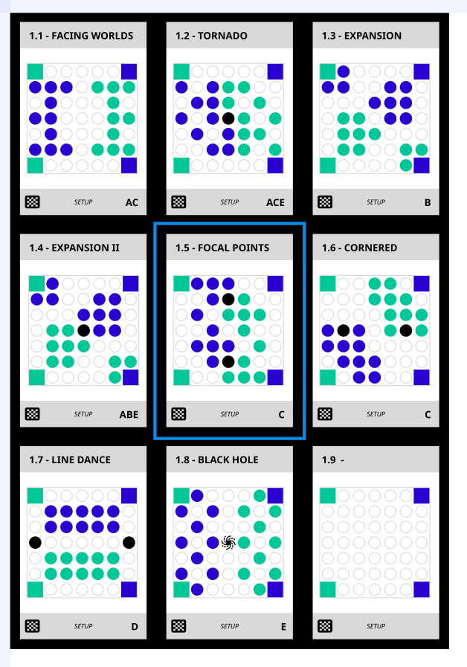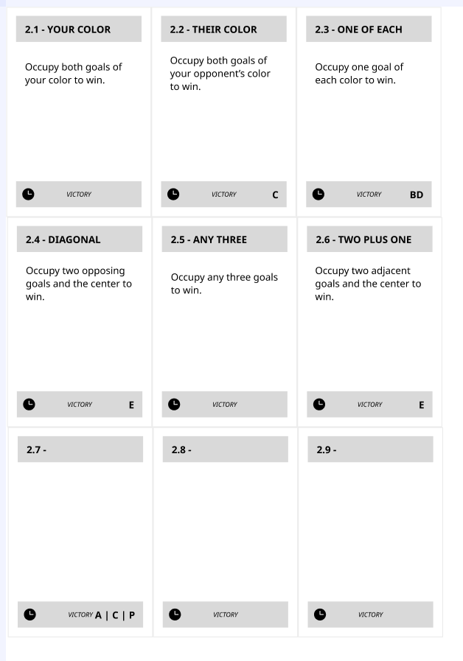

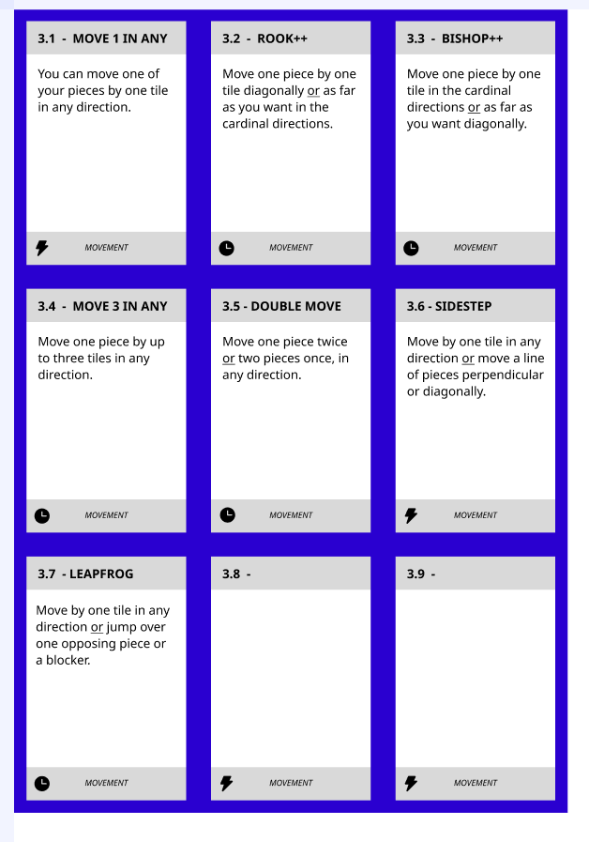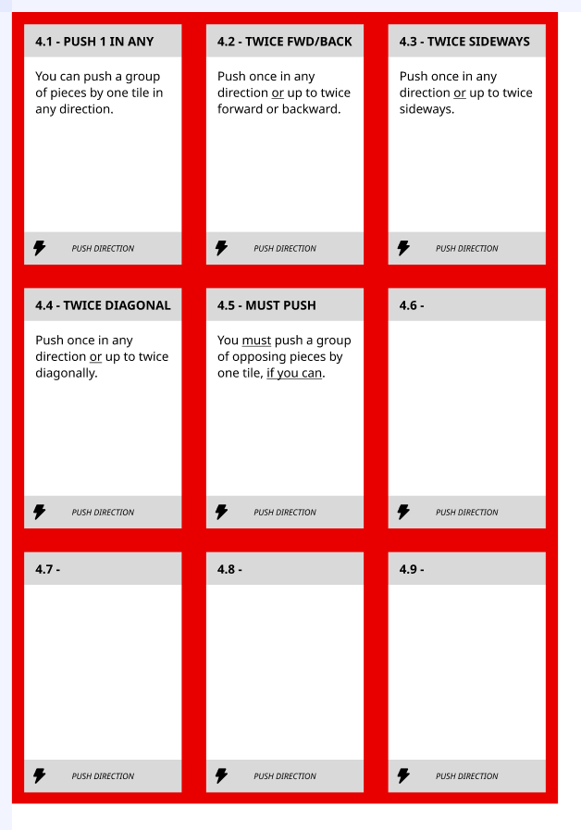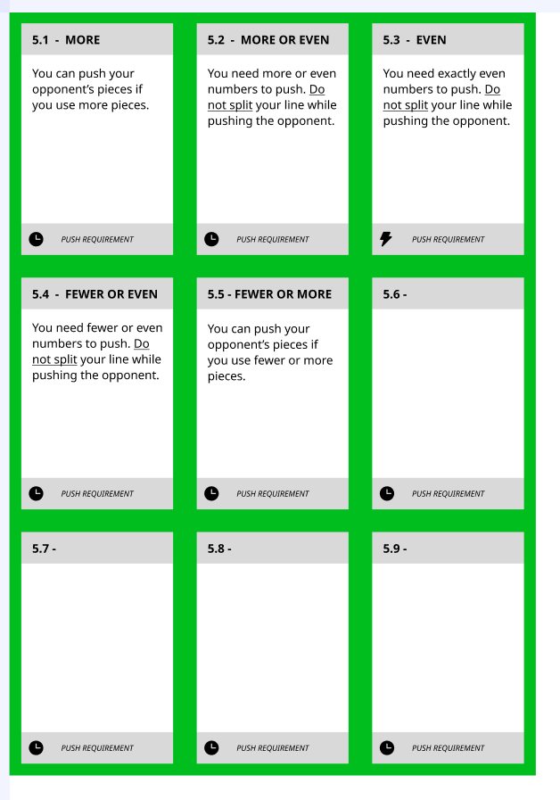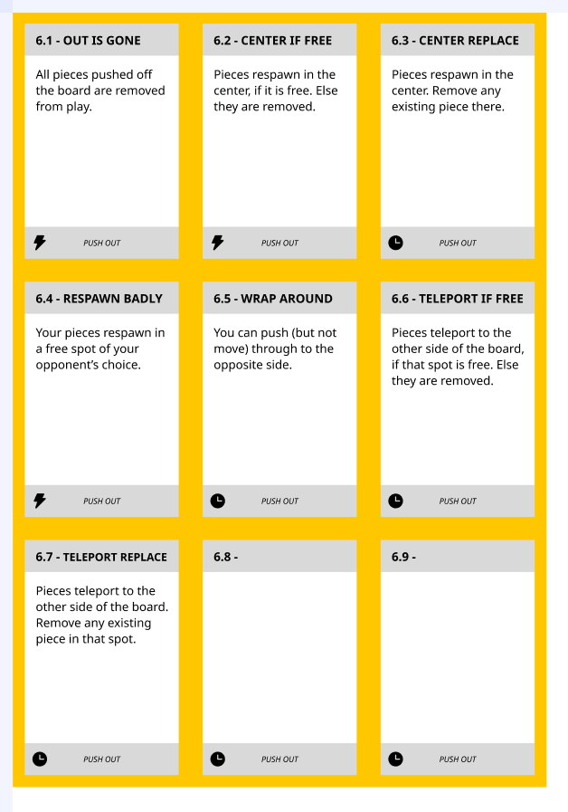

# **Research (Explorer’s) Log**

Want to document your journey? Here you can take notes to remember all the games you played … etc.

| **Round** | **Start Player** | **Winner** | **Rules Changed** | **Notes** |
| --- | --- | --- | --- | --- |
| *0* | *Hugo* | *Clara* | *Initial: 3.4*  *Later: 1.6 (Hugo), 5.4 (Clara)* | *Hugo had a great idea to go for the center early but Clara made their weakness into a strength.* |
| 1 |  |  | Initial:  Later: |  |
| 2 |  |  | Initial:  Later: |  |
| 3 |  |  | Initial:  Later: |  |
| 4 |  |  | Initial:  Later: |  |
| 5 |  |  | Initial:  Later: |  |
| 6 |  |  | Initial:  Later: |  |
| 7 |  |  | Initial:  Later: |  |
| 8 |  |  | Initial:  Later: |  |
| 9 |  |  | Initial:  Later: |  |

# 

# **House Rules & Additional Modifications**

Here go words about how, when you have played through all the existing rule cards, you can just shuffle them and play again but MAYBE you want to make your own house rules? This is how you do it, what you should consider/know and how you share them with other players.

* I could never get “push with fewer pieces” to work
* Here go other cards / combos that are known to be broken (and why)
* etc

Suggestions for how to **modify** the game if you want to (once you know it!)

* Remove marbles to give one player a handicap
* Draw more cards to choose from (+1 every game, slowly increase, not too fast!)
* Add your own house rules (mention things that did not work so far like “fewer”)
* Play each game twice to remove any first-player advantages (un-do the applied rule changes for this game … ?)